Joseph Lee, Adria Peterkin, Pedro Vicente

Integrating Nuclear and Renewable Energy

Round 3 Deliverable

The Electricity Grid is a network that conjoins different forms of power generation to be distributed for commercial or industrial usage. The grid is composed of three main sections: generation, transmission and distribution, and consumption. While each section of the grid maintains an autonomous and overall importance, the primary focus of this paper is to identify and analyze methods of energy generation.

The current US electrical grid utilizes multiple different sources of energy production; some of these forms include: Petroleum, Coal, Nuclear power, natural gas, and renewable energy. Amongst these varying sources, petroleum, coal, and natural gas dominate the market by about 82% of total energy generation. However, as institutions begin to push the significance of sustainability and lowering greenhouse gas emissions, there becomes an increasing need to substitute fossil fuel usage with sources that produce minimal green house gas emissions, such as nuclear power and renewable energy.

Renewable energy sources currently account for less then 10% of the electrical grid, according to 2015 Quadrennial Technology Review. The primary sources that have been incorporated in the mix include: solar, wind, geo-thermal, biomass, and hydropower. These sources are considered clean energy because they produce minimal to greenhouse gas emission throughout their plant lifecycle. Increasing the usage of these renewable sources not only reduces the amount of fossil fuels needed but in some cases can provide a decentralized electricity distribution. Assessing the disadvantages associated with these sources reflect the high cost of producing renewables compared to fossil fuels, and the difficulty with making the available energy to supply the grid during off peak times. For example, if the primary source of energy for a particular region is solar energy, it is expected that these panels will be able to handle periods of little to no sunlight. Although solar energy can still be collected during this time, is lowers the overall efficiency of the system. Furthermore, renewable energy play a critical role as it contributes to the electrical grid, but further development in this area is still needed for it to dominate the demand.

Nuclear Power Plants is another major component in the electrical grid. Although it does not fall under the category of renewable energy, it is considered a source of clean energy. Nuclear power plants have the ability to provide large amount of base load energy to grid with much less fuel required than a typical fossil fuel plant. Along with the current production of generation 4 nuclear power plants, variability can be used as an advantage as it creates ranges of the electrical and thermal output, and provides important safety components. Some of the disadvantages that has been associated with Nuclear Power plants includes it’s high cost, the public’s perception, and the time frame needed for plant construction. In order to efficiently move in the direction of clean energy, the disadvantages of these clean energy sources need to be addressed.

Providing energy to the US requires addressing a multitude of problems. Ideally, energy production methods should be reliable, clean, and affordable yet none of the methods currently being employed meet these criteria. To provide more context a reliable energy production method can supply energy to the grid at a controllable rate regardless of changing operating conditions. A clean energy source is able to produce electricity without polluting their local environment. Our main concern when considering a clean energy source is limiting the release of greenhouse gasses (GHG). Finally, an affordable energy production method not only maintains minimal operating expenses but also a low initial construction price

A preliminary analysis of the main energy production methods is performed in the following section to identify some of the strengths and weaknesses of each method.

**Fossil Fuels**

Around two thirds of the energy produced in the US comes from the burning of fossil fuels (1). The popularity of fossil fuels stems from the cheap construction and operating costs of fossil fuel plants and their ability to put produce a steady amount of electricity. Additionally, fossil fuels add stability to the electricity grid since they can be burned in diesel generators. While inefficient, these generators can quickly ramp up to full power to address changes in electricity demand or loss of power. Fossil fuels have obvious drawbacks in that they release pollutants to the ambient environment. Around 30% of all GHG produced in the US comes from the burning of fossil fuels for electricity. These GHG affect climate change around the world and the WHO estimates that the upwards of seven million people die every year (2).

**Renewables**

While only contributing to a small percentage of all the electricity in the US, renewables (mainly wind and solar) have the potential to address all the criteria for an ideal energy source. While renewables produce clean carbon free energy, they are far from affordable standing as the most expensive energy sources and reliable since their production depend on weather conditions which change frequently (3). Due to this dependence on weather, solar plants and wind farms cannot be incorporated all across the US and the rate of energy production cannot be controlled. This is especially significant for solar which produces large amounts of energy at low demand hours often leading to negative pricing of electricity which negatively impacts all energy production methods.

**Nuclear**

Like fossil fuels, nuclear energy produces electricity in a reliable rate but does not produce GHG during normal operating conditions. Unfortunately, growing regulations placed upon nuclear plants has made nuclear energy expensive even before the events at Fukushima. As it stands, these plants can cost the upwards of $5-10 billion and delays in construction can significantly affect this estimate. Recently, increasing contributions of erratic energy sources (renewables) has made nuclear less economical as prices fluctuate more frequently while nuclear energy production remains constant.

**Solutions to drawbacks**

There is much ongoing research to limit the negatives of the mentioned energy production methods. Reduction of carbon emissions in fossil fuel plants can come from using more natural gas plants over coal plants which have lower GHG emissions than coal, using a new integrated gasification combined cycle that would increase efficiency of energy production, or applying partial capture of carbon emissions (4-5).

For renewables, innovations are being made to make solar and wind production more efficient or cheaper. In the last thirty years, the cost of wind and solar energy has decreased by over a factor a ten. Furthermore, in order to better integrate renewables with other technologies, an efficient energy storage method can mitigate the excess energy production renewables bring and these can range from battery storage to heat storage in fire bricks.

The cost of nuclear can be significantly reduced by simplifying the design of power plants to use standard industry components that can be mass produced and incorporating shipyard building techniques that can reduce the construction time (6). Also, there are proposed designs for new nuclear reactors that would greatly increase the efficiency of energy production and safety over conventional reactors.

Just from a preliminary analysis of the main methods of energy production, it is clear that any of them individually will not be able to provide the necessary electricity to the grid while also meeting all three criteria originally listed. While there are many new technologies and techniques being researched that could bolster the strength of these energy production methods, an ideal solution to the clean energy issue should use multiple energy production methods in tandem to capitalize on the benefits of each and increase reliability through diversification.

**Our Proposal**

To deal with the previously mentioned challenges, we need the ability to “load follow” or match the energy output to the demand to prevent financial losses from excess energy being supplied to the grid when demand is low. Current nuclear reactors do not have this ability to ramp up or down their electricity production fast enough and thus are not able to effectively load follow. On the other hand, renewables don’t have the efficiency nor capacity to supply energy to the entire population. To fix these issues, we propose a nuclear-renewable integrated energy system consisting of an advanced nuclear reactor, specifically a molten salt reactor, coupled with a secondary industry process and a solar and wind farm.

The molten salt reactor is a generation IV fission reactor and it is based on the molten salt reactor experiment carried in the 1960s at the Oak Ridge National Laboratory. This class of reactors has many advantages compared to current pressurized water and boiling water reactors where the main advantage is that it uses a liquid fuel salt rather than solid fuel rods. The fact that it uses molten salt mitigates the need for a highly pressurized system necessary in light water reactors and the design comes with countless passive safety mechanisms that make it “walk away safe”.

The purpose of the secondary process is to take in excess energy in order to create a useful commodity that can later be sold. This helps load following efforts and an ideal process would be able to change production intensities to match different energy surpluses. On the more technical side, there are many adequate choices for the secondary process that depend on the thermal or electric requirements. Based in the fact that our reactor has an outlet temperature of around 700C we selected a four-step copper chloride hydrogen production process which only needs temperatures of upwards of 550C.

Since solar and wind are cyclical throughout the day, meaning that they only work when there is sun and/or wind, they will supply all the energy they produce to the electrical grid. The nuclear reactor will provide the other portion of the required electricity and the excess energy will be use to produce hydrogen. The hydrogen will be stored in pressurized tanks and sold in the market for a profit.This combination of processes means that all the energy will be use in more intelligent and efficient manner. When demand peaks, the hydrogen production rate can be stopped or slowed and during lows the rate can be resume or increase. The overall system then becomes efficient and highly profitable but more importantly it solves the problem with nuclear and renewables sources in an environmentally friendly way.

All members of the team will be working together in the design and integration of the individual technologies in a single system and work in the automatization of the overall grid/process. This will involve looking at the individual technologies and describing them in a detailed way to be able to interconnect them. This will be facilitated by the fact that the only design constraint is that the hydrogen plant needs to be directly coupled with the reactor. The solar and wind farms can be situated in different sites as long as they are connected to the same grid. An example of the system is portrayed in Figure 1 from the Idaho National Laboratory where the Nuclear energy sources is supplying electricity to the grid but also thermal energy to various secondary processes. In this example there is a thermal energy storage facility and different sources of solar energy.

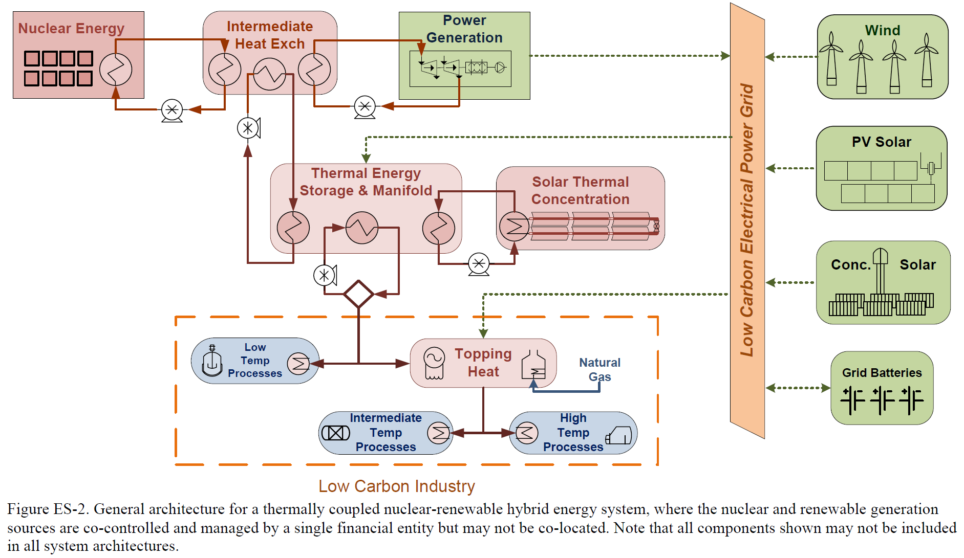

Figure 1. Nuclear-Renewables Integrated System from Idaho National Laboratory (Bragg-sitton et. al. 2016)

The first main challenge in the capstone project is the interconnection of the molten salt reactor and the hydrogen production plant. Once the system design is complete the next challenge is to find a way to automatize the whole grid to make it as efficient, economically and energetically, as possible. This means building an intelligent system capable of balancing the electricity output, from the nuclear reactor, and the hydrogen production rate depending on the grids demand and all this without the need of human operators intervention. The automatization design process will involve the modeling and simulation of different real life scenarios where energy demand varies during the day. The system should be able to adapt to these scenarios and run smoothly, safely and efficiently. Once all this goals are achieved the project will be complete.

References

Bragg-sitton, S. M., Boardman, R., Rabiti, C., Kim, J. S., Mckellar, M., Sabharwall, P., … Qualls, A. Lou. (2016). Nuclear-Renewable Hybrid Energy Systems : 2016 Technology Development Program Plan Idaho National Laboratory, (March).

“Carbon Emission and Mitigation Cost Comparisons between Fossil Fuel, Nuclear and Renewable Energy Resources for Electricity Generation.” *Fuel and Energy Abstracts*, vol. 45, no. 2, 2004, p. 102., doi:10.1016/s0140-6701(04)93161-x.

Doukelis, A., et al. “Partial O2-Fired Coal Power Plant with Post-Combustion CO2 Capture: A Retrofitting Option for CO2 Capture Ready Plants.” *Fuel*, vol. 88, no. 12, 2009, pp. 2428–2436., doi:10.1016/j.fuel.2009.05.017.

Jung, Dae-Yul, et al. “Advanced Construction Methods for New Nuclear Power Plants.” *ASME 2010 Pressure Vessels and Piping Conference: Volume 9*, 2010, doi:10.1115/pvp2010-25369.

“U.S. Energy Information Administration - EIA - Independent Statistics and Analysis.” *What Is U.S. Electricity Generation by Energy Source? - FAQ - U.S. Energy Information Administration (EIA)*, [www.eia.gov/tools/faqs/faq.php?id=427&t=3](http://www.eia.gov/tools/faqs/faq.php?id=427&t=3).

“7 Million Premature Deaths Annually Linked to Air Pollution.” *WHO*, World Health Organization, [www.who.int/mediacentre/news/releases/2014/air-pollution/en/](http://www.who.int/mediacentre/news/releases/2014/air-pollution/en/).